**English**

**Course**: 3rd year

**Date**: March, 27th

**Teacher**: Nátali Gómez

**Student**:

**Quantifiers: *some* (+) affirmative sentences, *any* (–), *any* (?) negative and interrogative sentences.**

1. **Mark the sentence + (aﬃrmative), – (negative) or ? (interrogative).**
   1. ? Is there **any** coﬀee?
   2. There isn’t **any** bread to make a sandwich.
   3. Are there **any** apples?
   4. There are **some** strawberries in the fridge.
   5. There’s **some** orange juice on the table.
   6. There aren’t **any** potatoes.
2. **Complete the conversation with *some* or *any*.**

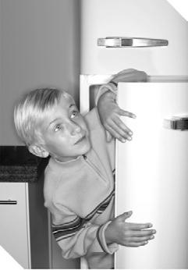

|  |  |  |  |  |  |  |  |  |  |  |  |  |  |  |  |  |
| --- | --- | --- | --- | --- | --- | --- | --- | --- | --- | --- | --- | --- | --- | --- | --- | --- |
| **Sam:** Hey, Mum! Have we got 1. **any** | | | | | | | | | | | | | | milk? | |  |
| I really want 2. | |  |  |  |  |  |  |  |  |  |  |  |  |  |  |  |
|  |  |  |  |  | cereal. | | | | | |  |  |  |
| **Mum:** No, there isn’t 3. | | |  |  |  |  |  |  |  | milk. | | | |  |  |  |
| **Sam:** Then I want a sandwich! Is there 4. | | | | | | | | | | | | | |  | bread? |  |
| **Mum:** No. I need to get 5. | | | | |  | | |  |  |  | bread the next time | | | | |  |
| I go to the supermarket. | | | | | | | |  |  |  |  |  |  |  |  |  |
| **Sam:** Well, but there is 6. | | | | | |  | |  |  |  |  | pizza, isn’t there? | | | |  |
| **Mum:** Sorry, Sam. There isn’t 7. | | | | | | | |  |  |  |  |  |  | pizza either. | |  |
| Have 8. |  | |  | salad! | | | |  |  |  |  |  |  |  |  |  |

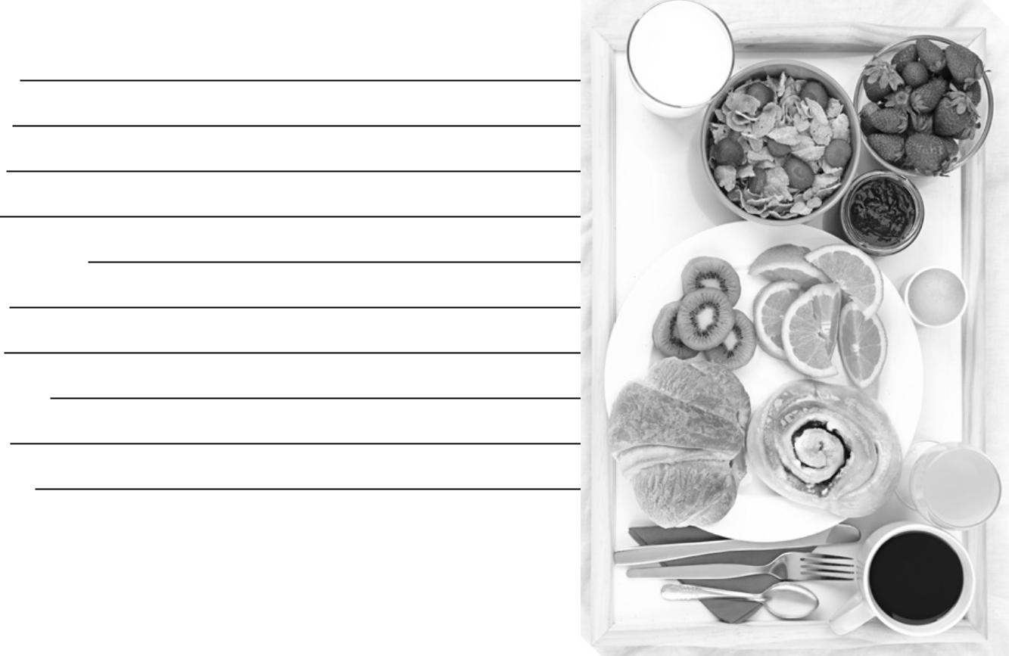

1. **Look. Then write sentences with *some* or *any*.**
2. orange apples

There are some oranges.

There aren’t any apples.

1. cereal
2. pasta
3. strawberries
4. coﬀee
5. bread
6. soft drink
7. butter
8. bananas



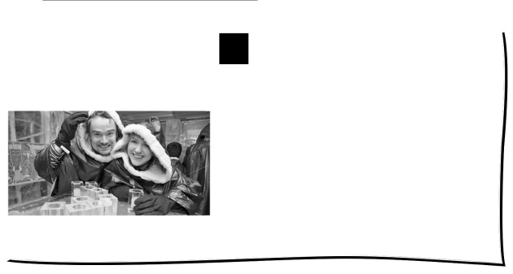**Restaurants Around**

**the World**

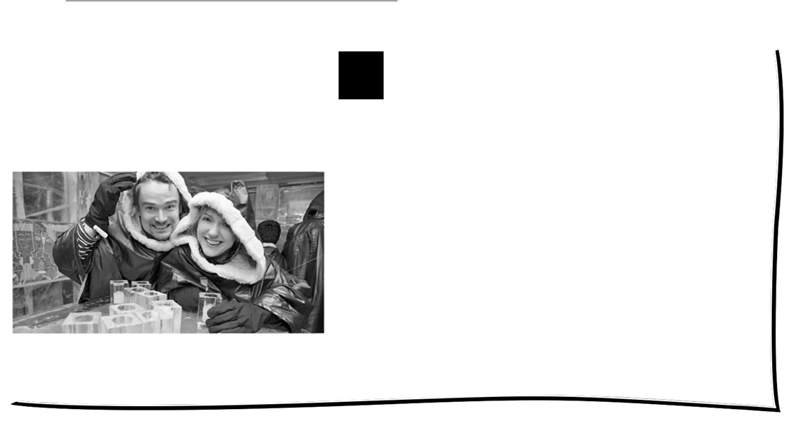

*These two friends like eating at an ice restaurant. Their* ***drinks*** *are in frozen glasses!*

**T** There are millions of restaurants around the world. Manyof them are similar: they have got tables, chairs, servers, customers and food. But some are very di erent!

Can you imagine eating dinner and not seeing your food? There are some restaurants that can serve food in the dark! The servers have got special **night-vision** glasses so they can see. Customers say that the food is very good!

Do you like **seafood**? You can eat some sh surrounded by sh at **aquarium** restaurants. Some are completely underwater—the whole restaurant is under water! Others are like normal restaurants with giant aquariums.

Some restaurants can **revolve** while the customers eat! They are usually on the top **oor** of a building. They can move very slowly and they have got a lot of windows!

There are restaurants in trees and restaurants that can oat on water. There are restaurants made of ice and restaurants that have got robot servers. Can you believe it? It’s true!

1. **Read and complete.**

 aquarium lights millions move servers water



|  |  |  |  |  |  |  |  |  |  |  |  |  |  |
| --- | --- | --- | --- | --- | --- | --- | --- | --- | --- | --- | --- | --- | --- |
| 1. | There are | | millions |  |  |  | of restaurants around the world. | | | | | | |
| 2. | At restaurants without | | |  |  |  |  |  | , the servers have got special glasses. | | | | |
|  |  |  | |  |  |  | |  |  |  |  |  |  |
| 3. | A revolving restaurant can | | | | |  | | |  | | . |  |  |
| 4. | Some |  |  |  | restaurants are completely underwater. | | | | | | | | |
| 5. | There are restaurants that float on | | | | | | |  |  | | | . |  |
| 6. | Some restaurants have got robots for | | | | | | | | . | | | | |
|  |  |  |  |  |  |  |  |  |  |  |  |  |  |

**2 Read and match.**

**Restaurants** **Activities**

1. restaurants in the dark move while you eat



2. aquarium restaurants drink from frozen glasses

3. revolving restaurants eat without light

4. ice restaurants eat surrounded by fish



**Stop and Think!** What is your favouriterestaurant? Why is it special?



1. **Glossary**



**night-vision:** see

in the dark

**seafood:** fish,

shrimp, crab, etc.

**aquarium:** glass

tank for fish

**revolve:** to move

in a circle

**floor:** level

**drinks:** beverages

Buenas chicos, espero estén bien. Las resoluciones de estas actividades inclúyanlas acá, y espero las respuestas de lo enviado la semana pasada.

Gracias.